Aeneas and Tabitha
Acts 9:32-43 on February 28, 2021
Pastor Jerry R. A. Johnson

Please read Acts 9:32-43 before going further in this transcript.
Last Sunday we talked about “Convincing Others.” Toward the end of the message I mentioned how Saul became a vigorous proponent of the gospel, and how this contributed to a time of peace in the Early church and an increase in the number of believers. For his own safety, the believers sent Saul up north to his hometown of Tarsus. And right after this, we’re given a summary of how well the church is doing in Acts 9:31 says, “Then the church throughout Judea, Galilee and Samaria enjoyed a time of peace and was strengthened. Living in the fear of the Lord and encouraged by the Holy Spirit, it increased in numbers.” I challenged us to prayerfully consider how God might be calling some of us to take a more active role, either in lay ministry or vocational ministry, either locally or globally. What I failed to mention though, and what I wish that I had thought to say, is that many of us are ALREADY serving, in the active role that God has called us to. We are already a vigorous proponent of the gospel, right where we currently are. Many of us are already in our own particular niche, in our current ministry and our current vocation. We’re “living in the fear of the Lord” and we’re being “encouraged by the HS” as we depend on God to sustain us as we serve Him. If this describes where you are at, then let me just say, “way to be! I praise God for you!” I praise God for the many faithful Christians who are living for Jesus as bus drivers, veterinary workers, counselors, and employees at Target, Walmart, Menards, Home Depot, and so on. As doctors, nurses, teachers, carpenters, and on and on. Wherever we’re working or going to school or raising our family or enjoying our retirement, it is commendable before the Lord, that we are living for Him, right where He’s placed us. So, I apologize for not thinking to mention that last week.
This idea of faithfully living for Jesus in our own particular niche, actually shows up in today’s text. We especially see it when we get to Tabitha. Please turn or tap in your Bible to Acts 9:32. Acts 9:32 begins, “As Peter traveled about the country, he went to visit the Lord’s people who lived in Lydda.” So Peter is out and about; he’s traveling all over the area. Throughout all of these various travels, visiting many different people in many different places, Luke, the author of the book of Acts, decides to record 2 particular miracles for us: one happened in Lydda and the other happened in Joppa.
[MAP] – Please take a look at the map on the back page of this transcript. Jerusalem is down in the lower right corner by the orange arrow. Jerusalem is in the region of Judea. If we then go north from Judea, we find the region of Samaria and then, way up on top, the region of Galilee. These are the three regions mentioned back in Acts 9:31, where the church was enjoying a time of peace. Now, beginning back down in Jerusalem (the orange arrow) we find that Peter headed west, over to Lydda and then Joppa (the 2 blue arrows).
Here’s the question though, in all of Peter’s various travels about the countryside, why did Luke decide to record these 2 particular miracles, about these 2 particular people, in these 2 particular places? Of all that was going on in the life of the Church throughout this entire region, why tell us about Aeneas and Tabitha? The most likely answer seems to be that…
1) Peter’s ministry to Aeneas and Tabitha reminds us of his authority as an apostle. You see, as we’ll discover in the very next chapter, Acts 10, God is about to charge Peter with the responsibility of leading the church in an EXTREMELY controversial direction… If you want to know more about this controversy, then I hope you’ll come back next Sunday.
Right before this extreme controversy, God sends Peter to perform 2 particular miracles: Healing a paralytic man and raising a woman from the dead. These 2 particular miracles harken us back to the earthly ministry of Jesus. And Luke, the author of Acts, seems to record them right here in Acts 9, on purpose, in order to further authenticate Peter’s apostolic authority. Even though we understand that these kinds of miraculous healings CAN still happen today, it’s important for us to remember that PETER, had been given specific ability to perform these miracles, as a part of God’s master redemptive plan. Let me show you what I mean…
Let’s take a closer look at these miracles. Peter’s 1st miracle was healing a paralytic man. In Acts 9:34 Peter says, “Jesus Christ heals you. Get up and roll up your mat.” This was much like the miracle Jesus had performed back in Mark 2:11 where Jesus says, “Get up, take your mat and go home.” So both Jesus and Peter heal a paralytic man. Although Peter makes it clear that Jesus is the one, doing the healing. Nonetheless, Peter is the chosen instrument that God uses. The main difference in the immediate phrasing are the words, “go home.” However, as one person has noted, “if Aeneas was in his own house when Peter healed him, he couldn’t very well “take his mat home,” but he could certainly roll it up and put it away. It’s also interesting to note that, after Jesus heals the paralytic in Mark 2:11, the people respond in the very next verse, in Mark 2:12 saying, “We have NEVER seen anything like this!” However, when Peter healed Aeneas, many of the believers would have more likely responded by saying, “We HAVE seen something like this before!”
We should also note, that when Jesus heals the paralytic, He clarifies how it is directly connected to his authority to forgive sin. In Mark 2:9-10 Jesus asks, “Which is easier: to say to this paralyzed man, ‘Your sins are forgiven,’ or to say, ‘Get up, take your mat and walk’? But I want you to KNOW that the Son of Man has authority on earth to forgive sins….” After Peter heals the paralytic in Lydda, Acts 9:35 records, “All those who lived in Lydda and Sharon (which is nearby) saw him and turned to the Lord.” In other words, they had their sins forgiven in Jesus’ name. This miracle in Lydda reminds us that Peter’s authority as an apostle is DIRECTLY connected to Jesus’ authority to heal and Jesus’ authority to forgive sins.
Peter’s 2nd miracle was raising Tabitha from the dead. Acts 9:40 says, “Peter sent them all out of the room; then he got down on his knees and prayed. Turning toward the dead woman, he said, “Tabitha, get up.” She opened her eyes, and seeing Peter she sat up.” This was much like the miracle Jesus performed for Jairus’ daughter, back in Mark 5:40-41, “…After [Jesus] put them all out, he took the child’s father and mother and the disciples who were with him, and went in where the child was. He took her by the hand and said to her, “Talitha koum!” (which means “Little girl, I say to you, get up!”).” So both Jesus and Peter raised a woman from the dead. Although clearly Jesus heals a little girl and Peter a full-grown woman, named Tabitha. Peter was actually there with Jesus in Mark 5, right there in the very room where Jesus healed this little girl. So certainly Peter would have noticed the direct comparison between these 2 miracles. John Stott makes an interesting comparison between Acts 9 and Mark 5. He notes that IF Peter spoke in Aramaic when he raised Tabitha, there would have only been a one letter difference between what Jesus said and what Peter said:
“Tabitha koum!” vs. “Talitha koum!” (Tabitha, get up! vs. Talitha, get up!)
In other words, apparently, “The parallel is no accident. Peter’s ministry shows that Jesus is still at work.” So it does indeed seem, that the reason Luke included these two particular miracles, at this strategic point in the book of Acts, was to remind us of Peter’s authority as an apostle.
However, all of this being said, this doesn’t need to lesson, in any way, the important role that this miracle played, in the salvation of SO MANY people living in Joppa. Acts 9:42 says, “This became known all over Joppa, and many people believed in the Lord.” In fact, let’s think about this: many people believed; people all over Joppa. And how did all of this originate? Why did Peter even come to Joppa in the first place? Acts 9:38 tells us, “Lydda was near Joppa; so when the disciples heard that Peter was in Lydda, they sent two men to him and urged him, “Please come at once!” Now arguably, Peter may have eventually made it to Joppa one way or another, on his own timing. However, it seems clear that God’s timing for Tabitha’s healing was part of His master redemptive plan. Another part of God’s master redemptive plan, was the very thing that prompted the disciples in Joppa to send for Peter in the first place: Tabitha’s godly character and her reputation for “always doing good and helping the poor.”
2) Tabitha’s ministry reminds us of the importance of faithfully living for Jesus in our own particular niche. Acts 9:36 says, “In Joppa there was a disciple named Tabitha (in Greek her name is Dorcas); she was always doing good and helping the poor.” So, the point we’re driving at here, is that Tabitha’s faithful Christian testimony, is what inspired the believers to send for Peter. And this then led, not only to Tabitha being raised from the dead, and returned to these dear widows, but also to many people finding eternal life, through her Lord/Savior Jesus Christ. To be clear, Tabitha is NOT listed as a particularly high-ranking leader in the church or a key political official, or anything like that.
In fact, there’s nothing to suggest that she was anyone of particular note or prominence. (And yet, she kind gives us a Mother Theresa vibe.) And yet, God used her faithful, behind-the-scenes ministry, not only to bless the widows and help the poor, but also as a catalyst so that MANY people came to believe in the Lord.
It’s interesting to note how Luke takes time to mention these seemingly insignificant, yet vital details in the life of a healthy church. Right in the midst of all the incredible miracles and bold, gospel proclamations, and people being martyred and thrown in jail for their faith, Luke also takes time to mention the behind-the-scenes ministries of people like Tabitha. We found another example of this, back in Acts 6 when we learned about the Early Church’s commitment to feeding the widows who didn’t have other means of support. Now, here again, at the end of Acts 9, Luke takes time to give us a glimpse of the everyday love/support among the believers. Caring for those in need is something that the Early Church prioritized and made allowances for. We are called to protect and provide for, those who may need a helping hand from time to time. This is pleasing to God because it’s godly behavior. Having a behind-the-scenes ministry does not make that ministry inconsequential; not in the least. Tabitha’s life and ministry stands as a lasting testimony to the immense value of those who faithfully live for Jesus in their own particular niche. Tabitha’s ministry gives us a helpful glimpse inside of a healthy, happy church that is plugging along in their devotion to Jesus and in their service to one another.
This is why our church has been working on putting together a Servant Team. We talked about this back in November and we’re continuing to make headway. “What’s the Servant Team all about? Well, I’m so glad you asked! Our Servant Team is a group of men/women who can help with practical needs of people in our church family. Needs like shoveling snow, picking up groceries, or building a wheelchair ramp. Needs like cleaning someone’s house, helping with lawn care, or helping someone move. These kinds of needs are far more than our Visitation Caregiver or our pastors can do by themselves; it takes the whole body serving together. So we need some people with this kind of gifting and calling to JOIN our Servant Team. If SERVING is your particular ministry niche, then please email the church at Efree@PaulBunyan.net or visit our website: www.efcbemidji.org/serve Our website also lists some other ways of serving, such as helping with our Technology Team or serving as part of our Welcome Table ministry. We’re going to wrap up today’s message by doing something a little different. Now, by different, I’m just giving you a heads up, that I’m going to ask you to leave your comfort zone, just a little. Consider this an attempt to fight back against Cabin Fever a little. We’re going to do 2 things; we’re going to learn a Greek word and then we’re going to memorize a Bible verse.
1) The Greek word is ἐγκακέω (enkak$\acute{e}$o > “en kaa KE oh”) Enkak$\acute{e}$o means to get tired of something or to lose motivation and enthusiasm for continuing with a desirable activity.
So, please try and say this word out loud a few times, “enkak$\acute{e}$o.” Use the pronunciation hint above.
If you are already getting tired of this, I hope that you can at least see the irony of losing the motivation to do this (see the definition for enkak$\acute{e}$o ) At times, we do grow tired of doing good in this world, but Tabitha reminds us to always keep doing good.
2) The memory verse is 2 Thessalonians 3:13, which says “Brothers and sisters, never get tired of doing good.” (ERV – Easy to read version) Never “enkak$\acute{e}$o” of doing good.
Now, if you believe in the importance of memorizing God’s Word and hiding it in your heart, then why not try memorizing this simple verse? (Last Sunday a few people made fun of me for singing Justin Bieber’s “Baby, baby, oh.” Well, now it’s your turn BABY!) At church I was able to teach us the song form of this memory verse. However, there’s not an easy way to do that in a written transcript. So, you’ll either need to jump online and fast forward to the end of the message so that you can hear the tune or you’ll need to make up your own tune for this verse. The best part of singing this is that it comes right out of Scripture!
The tune I led uses these words, “Never⁶ …get tired of doing good. 2 Thes. 3:13!” I added some finger snapping for rhythm and we repeated the word “never” 6 times. Regardless of how you may choose to memorize this on your own, I encourage you to meditate on this simple message.
It’s the same message we see in places like Galatians 6:9-10, “Let us not become weary in doing good, for at the proper time we will reap a harvest if we do not give up. Therefore, as we have opportunity, let us do good to all people, especially to those who belong to the family of believers.” Brother or Sister in Christ, do good this week in Jesus’ name!

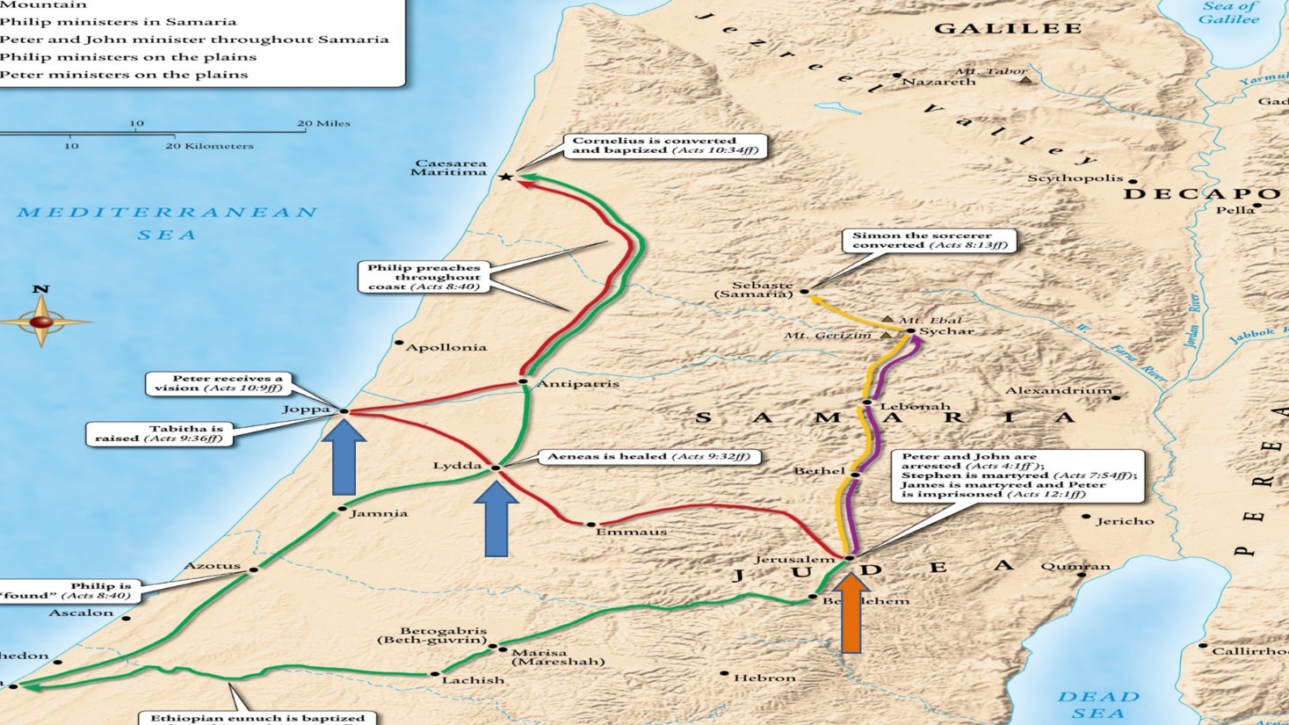

“ih NEE uhs” Severance, W. M., & Eddinger, T. (1997). In That’s easy for you to say: your quick guide to pronouncing Bible names (p. 19). Nashville, TN: Broadman & Holman Publishers.
Kevin DeYoung’s sermon “The Hater Becomes the Hated,” Acts: A Visual Guide, Christian Focus Publications, Scotland, 2018.
These words are also recorded in Matthew 9:6 and Luke 5:24.
F.F. Bruce makes this helpful observation in The Book of Acts, Rev., Eerdman’s, Grand Rapids, MI, 1988, p. 198.
By the way, Peter may have sent them out because of the noise from the heartfelt weeping (see Mark 5:38, 40). More likely though, he wanted to avoid drawing excess attention to himself. (Darrell L. Bock, Acts, Baker, Grand Rapids, MI, 2007, p. 378).
TAL ih thuh KOOM vs. TAB ih thuh KOOM. Severance, W. M., & Eddinger, T. (1997). In That’s easy for you to say: your quick guide to pronouncing Bible names (p. 153). Nashville, TN: Broadman & Holman Publishers.
John R. W. Stott, The Message of Acts, IVP, Downers Grove, IL, 1990, p. 183.
“‘Tabitha, get up’ would have sounded almost identical in Aramaic to Jesus’ words ‘talitha koum’ (‘little girl, get up’) in Mark 5:41, illustrating the close relationship between the apostles’ miracles in Acts and Jesus’ miracles in the Gospels. Both evidence the in-breaking power of the kingdom of God.” NIV Zondervan Study Bible, Grand Rapids, MI, 2015 pp. 2237-2238 footnote on Acts 9:40.
Also consider Jesus statement, “they will do greater things than these” in John 14:12.
Darrell L. Bock, Acts, Baker, Grand Rapids, MI, 2007, p. 378.
“Luke deliberately portrayed Peter as an authentic apostle of Jesus Christ, who performed ‘the signs of a true apostle.’” (John R. W. Stott, The Message of Acts, IVP, Downers Grove, IL, 1990, p. 183.) In 2 Corinthians 12:12 the Apostle Paul says, “I persevered in demonstrating among you the marks of a true apostle, including signs, wonders and miracles.”
In fact, in Matthew 16:18 Jesus said, “And I tell you that you are Peter, and on this rock I will build my church, and the gates of Hades will not overcome it.”
Lydda was about a day’s journey from Joppa by foot (Darrell L. Bock, Acts, Baker, Grand Rapids, MI, 2007, p. 376). Therefore, it took them about a day to travel from Joppa to Lydda to tell Peter, then another day for Peter to travel from Lydda to Joppa. It’s about 12 miles one way (The NIV Study Bible, Zondervan, Grand Rapids, MI, 2011, p. 1843 footnote on Acts 9:32).
This could also indicate that she was wealthy. Darrell L. Bock, Acts, Baker, Grand Rapids, MI, 2007, p. 377.
See Deuteronomy 15:7-11; Proverbs 19:17; Galatians 2:10; James 1:27; and 1 John 3:16-18.
This is an example of a “gamma nasal” where the “g” sound is actually an “n” sound because the gamma is followed by a kappa “k.” William D. Mounce, Basics of Biblical Greek, Zondervan, Grand Rapids, MI, 1999, pp. 9-10.
Arndt, W., Danker, F. W., Bauer, W., & Gingrich, F. W. (2000). A Greek-English lexicon of the New Testament and other early Christian literature (3rd ed., p. 272). Chicago: University of Chicago Press.
It’s also used in Galatians 6:9; 2 Corinthians 4:1; Ephesians 3:13; and Luke 18:1.

