Choosing Saul
Acts 9:1-19a on February 14, 2021
Pastor Jerry R. A. Johnson

Please read Acts 9:1-19a before going further in this transcript.
The longer we follow Jesus, the more we grow to understand just how AMAZING His grace truly is. 1 Corinthians 1:26-28 urges us, “Brothers and sisters, think of what you were when you were called. Not many of you were wise by human standards; not many were influential; not many were of noble birth. But God CHOSE the foolish things of the world to shame the wise; God CHOSE the weak things of the world to shame the strong. God CHOSE the lowly things of this world and the despised things—and the things that are not—to nullify the things that are.” Aren’t you glad that God isn’t too picky? Aren’t you glad that He has a soft spot for those of us who are foolish, weak, and lowly? Today’s message is on “Choosing Saul.” This text teaches us some vital truths about God’s choosing.
This passage in Acts 19 gives us a brief summary of Saul’s conversion to Christianity. This man, Saul, who began as a fierce opponent of Christianity, had his life spun around 180 degrees, by an encounter with the living Christ. Please turn in your Bible to Acts 9:1. Acts 9:1 begins, “Meanwhile, Saul was still breathing out murderous threats against the Lord’s disciples….” So Saul is just as fired up now, as he was back in Acts 8, when he gave approval to Stephen’s stoning and then began to DESTROY the church. In fact, he’s even more fired up! Saul’s not content with only raising havoc in Jerusalem. Acts 9:1-2 continues, “…He went to the high priest and asked him for letters to the synagogues in Damascus, so that if he found any there who belonged to the Way [Christians], whether men or women, he might take them as prisoners to Jerusalem.”
MAP – Take a look at the map on the back of this transcript. Damascus was about 150 miles NE of Jerusalem, located in the Roman province of Syria, where many Jews lived. Damascus was a central hub for commercial trade, reaching well beyond the confines of Judea, Samaria, and Galilee. Apparently, Saul’s strategy was to stop the spread of Christianity before it could be fully established in Damascus, and then spread even further beyond Damascus, to the ends of the earth!
Jesus appeared to Saul while he was on his way to Damascus. He sends him into the city where Saul ends up at the house of Judas on Straight Street. Jesus then sends a guy named Ananias there. Now at first, Ananias is not too sure about this plan. In Acts 9:13-14 he says, “Lord…I have heard many reports about this man and all the harm he has done to your holy people in Jerusalem. And he has come here with authority from the chief priests to arrest all who call on your name.” Ananias wants to make sure that he heard the Lord correctly: “Lord, you want me to visit the guy who approved of Stephen’s murder, the one who’s been dragging people off to jail? The one with the letters authorizing the arrest of Christians living in Damascus, Christians like, oh I don’t know maybe… ME!?” In Acts 9:15 “…the Lord said to Ananias, ‘Go! THIS MAN is my chosen instrument….’” Given all that we know about Saul up to this point, he seems like one of the LEAST likely candidates for becoming a Christ-follower. Even so, the Lord CHOOSES Saul. It’s interesting to note that the Lord sent a guy named “Ananias,” when he chose Saul. You see, “Ananias” is the Greek form of the Hebrew name “Hananiah,” which means “the LORD is gracious/shows grace.”
Choosing Saul reminds us that…
1. Even the “least likely to get saved” are NOT beyond God’s grace. Saul explains it this way in 1 Timothy 1:12-14, “I thank Christ Jesus our Lord, who has given me strength, that he considered me trustworthy, appointing me to his service. Even though I was once a blasphemer and a persecutor and a violent man, I was shown mercy because I acted in ignorance and unbelief. The grace of our Lord was poured out on me abundantly, along with the faith and love that are in Christ Jesus.” Brother or Sister in Christ, it’s vital that we understand this simple truth: Even the “least likely to get saved” are NOT beyond God’s grace. There’s a tendency for us, to write certain people off. Perhaps you’re thinking about them right now. Someone who seems SO FAR away, from ever putting their trust in Jesus. It might be a longtime friend or family member. It might be someone from work or school. Someone who, if we were entirely honest, seems WAY beyond EVER becoming a Christ-follower.
Whenever we allow ourselves to think that someone is beyond God’s grace, it’s a mistake. It’s a mistake because it was no less of a miracle when God saved us from our sin. In fact, it would be a bit arrogant if we allowed ourselves to conclude, that OUR salvation was somehow one of the “easy ones.” That somehow, we weren’t as lost and sinful as someone else who is in “greater” need of salvation, or whose sins are worse than ours. Later on in his life, Saul penned this reminder to his fellow believers in Ephesians 4:1-3, “… you were dead in your transgressions and sins, in which you used to live when you followed the ways of this world and of the ruler of the kingdom of the air, the spirit who is now at work in those who are disobedient. All of us also lived among them at one time, gratifying the cravings of our flesh and following its desires and thoughts. Like the rest, WE were by nature deserving of wrath.” Even the “least likely to get saved” are NOT beyond God’s grace. Choosing Saul also reminds us that…
2. God faithfully pursues us before our day of salvation. Acts 9:3-4 says, “As he neared Damascus on his journey, suddenly a light from heaven flashed around him. He fell to the ground and heard a voice say to him, ‘Saul, Saul, why do you persecute me?’ ‘Who are you, Lord?’ Saul asked. ‘I am Jesus, whom you are persecuting,’ he replied.” When we read Acts 9, about the day when light SUDDENLY flashed out of the sky and Jesus spoke to Saul, it may seem to us like this was the very first time that the Lord pursued Saul. But it would be wrong for us, to conclude from just this one particular account, that God hadn’t been doing anything else in Saul’s life up to this point. On the contrary, there is good evidence to suggest that God had been faithfully pursing Saul for his day of salvation for quite some time now.
Let’s consider this: later on in Acts, when Saul is sharing his testimony before King Agrippa, he gives us an intriguing piece of extra information. Jesus words are recorded in Acts 26:14 “…Saul, Saul, why do you persecute me? [then Jesus also said] It is hard for you to kick against the goads.” A goad is a sharp stick used to prod an ox; it keeps them moving along and doing whatever the farmer wants them to do. The point Jesus is making, is that it’s useless to resist the goads. The stubborn ox only ends up hurting itself. What does Saul’s persecution of Christians have to do with Saul being goaded? Well, apparently, the more Saul chose to kick against these Christians, the more he found himself kicking against Jesus. You see, Saul wasn’t just persecuting Christians, he was also persecuting Jesus Himself. Notice the wording, “why do you persecute ME.”
For example, back when Saul helped with the persecution of Stephen, It was his first step on the path of persecuting Jesus. But in hindsight, it was one of the goads that God used to prod Saul towards faith. You see, Saul was not only there in Acts 8, giving approval of Stephen’s killing, but he had been there in Acts 7 to hear Stephen’s speech. John Stott points out that Saul was there to witness Stephen’s “courageous non-resistance while being stoned to death… [and] his prayer for the forgiveness of his executioners…. [you see] There was something inexplicable about those Christians – something supernatural, something which spoke of the divine power of Jesus.” Therefore, we can’t help but consider how the Lord used Stephen’s testimony, as one of the goads in Saul’s life, prodding him toward faith. Certainly, Stephen’s speech and martyrdom must have gotten Saul thinking. If not during Stephen’s killing, then at least afterwards, as the violent images of his murder burned into Saul’s memory, right alongside Stephen’s unforgettable, rock solid faith in Jesus.
Saul may very well have thought that once Stephen had been put to death and the Christians in Jerusalem were arrested, surely this Christian movement would come to a screeching halt. However, the more he kicked against the goads, the more he kicked these Christians, the more he kicked against Jesus, the harder things got for him. For some reason, these Christ-followers seemed unstoppable! In fact, Saul ends up learning firsthand, something his rabbi, Gamaliel, had warned about back in Acts 5. Saul had studied in Jerusalem under Gamaliel, so he likely paid close attention to all of his rabbi’s speeches. Gamaliel had warned the entire Sanhedrin back in Acts 5:38-39, “…Leave these men alone! Let them go! For if their purpose or activity is of human origin, it will fail. But if it is from God, you will not be able to stop these men; you will only find yourselves fighting against God.” There seems to be a connection when we compare Acts 5:39, “you will only find yourselves fighting against God,” with Jesus’ words in Acts 26:14, “It is hard for you to kick against the goads.” In other words, when Saul falls to the ground on his way to Damascus, he is finally forced to admit, that his REAL fight, ALL ALONG, has been against God Himself.
In some ways, Saul’s conversion to Christianity equates with the testimony of C. S. Lewis. Lewis doesn’t use the word picture of a stubborn ox being goaded, but he does use something close. In the final chapters of his autobiography, C. S. Lewis describes God’s RELENTLESS pursuit of him using various word pictures: He likens God to a great fisherman who knows just how to play the fish; to a cat who is particularly adept at chasing down mice; to a team of well-trained dogs closing in on a fox; and to a Grandmaster chess player who has maneuvered ALL of the pieces on the chessboard, in such a way that his opponent is forced to concede… ‘checkmate.’
Acts 9:18 says that when Ananias placed his hands on Saul, “something like scales fell from Saul’s eyes.” God graciously removed Saul’s spiritual blindness so that he could see his immediate and overwhelming need for Jesus. 2 Peter 3:9 reminds us, “…[The Lord] is patient with you, not wanting anyone to perish, but everyone to come to repentance.” God faithfully pursues us before our day of salvation. The reason this is SO important for us to realize, is that it gives us the hope and motivation we need to keep praying for the spiritually lost people we know and to keep pursuing them. In Acts 9, God was choosing Saul, this week, he may be choosing someone that you’ve been witnessing to. God continues to faithfully pursue our lost friends and relatives.
Later on in his life, Saul shares an amazing call to worship in 1 Timothy 1:15-17.
“Here is a trustworthy saying that deserves full acceptance: Christ Jesus came into the world to save sinners—of whom I am the worst. But for that very reason I was shown mercy so that in me, the worst of sinners, Christ Jesus might display his immense patience as an example for those who would believe in him and receive eternal life. Now to the King eternal, immortal, invisible, the only God,
be honor and glory for ever and ever. Amen.”
Brother or sister in Christ, let’s worship God for His Amazing Grace! As a response to this message, read or sing out the words of the famous old hymn “Amazing Grace.”

Amazing grace! How sweet the sound. That saved a wretch like me!
I once was lost, but now am found; Was blind, but now I see.
’Twas grace that taught my heart to fear, And grace my fears relieved.
How precious did that grace appear the hour I first believed.
The Lord has promised good to me, His Word my hope secures.
He will my Shield and Portion be, as long as life endures.
Through many dangers, toils, and snares, I have already come.
’Tis grace hath brought me safe thus far, and grace will lead me home.
When we’ve been there ten thousand years, bright shining as the sun,
We’ve no less days to sing God’s praise than when we’d first begun.

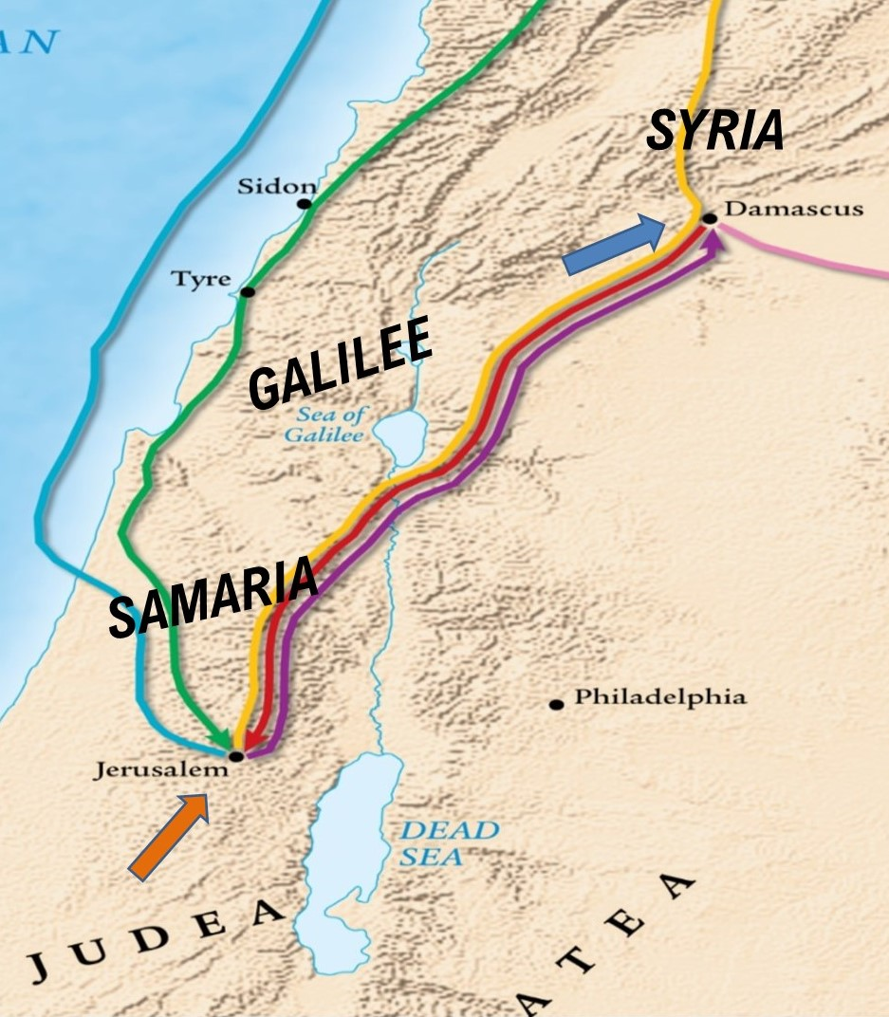

See John R. W. Stott, The Message of Acts, IVP, Downers Grove, IL, 1990, p. 168.
Saul “was in no mood to consider the claims of Christ. His heart was filled with hatred and his mind was poisoned by prejudice…He had left out of his calculations the sovereign grace of God.” John R. W. Stott, The Message of Acts, IVP, Downers Grove, IL, 1990, p. 169.
The NIV Study Bible, Zondervan, Grand Rapids, MI, 2011, p. 1841 footnote on Acts 9:2.
See map and notes in The NIV Study Bible, Zondervan, Grand Rapids, MI, 2011, bottom of p. 1842.
In other words, Christianity had slipped through the net that Saul had set up in Jerusalem. (See John R. W. Stott, The Message of Acts, IVP, Downers Grove, IL, 1990, p. 168.) He was now hoping for containment in Damascus before it spread any further. However, as we will see throughout the book of Acts, the harder the enemies of the church squeezed the Christ-followers, the more they slipped through their fingers to spread the Gospel even further.
By bringing the Christians back to Jerusalem, it would ensure that they would come under the full authority of the Sanhedrim who ruled from there. The NIV Study Bible, Zondervan, Grand Rapids, MI, 2011, p. 1841 footnote on Acts 9:2.
Saul wanted letters from the high priest because he “had authority over Jews both in Judea and elsewhere.” The NIV Study Bible, Zondervan, Grand Rapids, MI, 2011, p. 1841 footnote on Acts 9:1.
It’s possible that “Straight Street is a bit of a play on words hinting that Paul straightened out. If you look at a map of Damascus, you can see why they call it Straight Street, because all of the other streets are winding/crooked. The NIV Study Bible, Zondervan, Grand Rapids, MI, 2011, p. 1841 footnote on Acts 9:11.
In fact, if you were to travel to modern-day Damascus, you would still find this straight street there today. Now it is called “Darb el-Mostakim.” The NIV Zondervan Study Bible, Grand Rapids, MI, 2015, p. 2235 footnote on Acts 9:11.
See also Acts 26:9-11.
I’m curious, when he first entered the house where Saul was staying, if Ananias looked over and saw Saul’s satchel lying on the floor, and then wondered to himself whether the letters from the high priest were in there. Letters that authorized Saul to arrest Ananias and drag him off to prison some 150 miles away in Jerusalem.
The NIV Study Bible, Zondervan, Grand Rapids, MI, 2011, p. 1841 footnote on Acts 9:10.
Some of these “least likely candidates” are listed in 1 Corinthians 6:9-11, “Or do you not know that wrongdoers will not inherit the kingdom of God? Do not be deceived: Neither the sexually immoral nor idolaters nor adulterers nor men who have sex with men nor thieves nor the greedy nor drunkards nor slanderers nor swindlers will inherit the kingdom of God. And that is what some of you were. But you were washed, you were sanctified, you were justified in the name of the Lord Jesus Christ and by the Spirit of our God.” Also consider 1 Timothy 1:9-11.
When Jesus captured Saul with His sovereign grace, we shouldn’t necessarily assume that it was either sudden or mandatory. See John R. W. Stott, The Message of Acts, IVP, Downers Grove, IL, 1990, p. 171.
The NIV Study Bible, Zondervan, Grand Rapids, MI, 2011, p. 1877 footnote on Acts 26:14.
In other words, when you mess with the Lord’s people, you are also messing with the Lord Himself.
It stands to reason that when Stephen was dragged out of the city in Acts 7:58, that the reason they laid their coats at Saul’s feet was that he had been there for the whole ordeal.
John R. W. Stott, The Message of Acts, IVP, Downers Grove, IL, 1990, p. 172.
See Acts 22:3 and the footnotes in The NIV Zondervan Study Bible, Grand Rapids, MI, 2011, p. 1871.
Admittedly, we can’t be certain whether Saul was there when Gamaliel gave his address before the Sanhedrin, but it seems likely that Saul would have at least heard about his persuasive speech. After all, Jerusalem was in quite an uproar at this time given all of the signs and wonders that the Apostles had been performing in Jesus’ name.
In other words, throughout Saul’s life, and particularly during the time that he was lashing out against the Christians, he had actually been embroiled in his own personal wrestling match with God.
C. S. Lewis, Surprised by Joy being referenced by John R. W. Stott, The Message of Acts, IVP, Downers Grove, IL, 1990, p. 171.
G. K. Chesterton wrote a poem called, “The Hound of Heaven.” (Learn more at https://brandonvogt.com/grace-filled-poem-g-k-chesterton-j-r-r-tolkien-loved/) In this poem, God Himself is the Hound of Heaven. He “chases down a wayward soul, never giving up pursuit, ‘down the nights and down the days…down the labyrinthine ways.’” (Brandon Vogt quoting Chesterton in part at https://brandonvogt.com/grace-filled-poem-g-k-chesterton-j-r-r-tolkien-loved/)
Over time, the grace of God slowly wore down Saul’s defenses, freeing him from his pride and stubbornness. See discussion by John R. W. Stott, The Message of Acts, IVP, Downers Grove, IL, 1990, p. 173.
God had been faithfully working in Saul’s life, preparing him for the day of his salvation. Just like C. S. Lewis, Saul’s conversion wasn’t “all of a sudden.” In fact, no one’s conversion really happens “suddenly.” God’s gracious pursuit of us, reveals that He patiently, lovingly chips away at our resistance.
John Newton, 1779.

